
TOBB ETU
Economy & Technology University
BIL 495 / YAP 495

Project Management Plan (PMP)
Reference: IEEE 1058 / ISO/IEC 12207

1. Project Overview
2. Organization and Roles
3. Project Schedule
4. Budget and Resources
5. Risk Management
6. Quality Assurance
7. Appendix
8. References

1. Project Overview
In Neonatal Intensive Care Units (NICUs); medical devices, sensors, and Hospital Information Systems (HIS) often operate independently and use incompatible data formats, which prevents clinicians from obtaining a unified, real-time view of newborns’ medical conditions. Moreover, raw data from sensors are frequently noisy, incomplete, or non-standardized; which reduces the accuracy and reliability of AI-based diagnostic and monitoring systems.
Clinicians also lack an integrated platform that consolidates historical patient records, AI-generated diagnostic results, and updated clinical guidelines. As a result, clinical decision-making becomes slower, less consistent, and more prone to human error.
To address these issues, there is a clear need for a secure, interoperable, and real-time digital decision support infrastructure that can unify all NICU data sources—IoMT devices, HIS platforms, and AI diagnostic modules—under standardized protocols such as HL7, DICOM, and FHIR.

2. Organization and Roles
List roles, team members, and responsibilities.
Team members:
- Ali Belikırık
- Beyza Değirmenci
- İnan Özşahin
- Özge Doğan

3. Project Schedule

Project | Start Date | End Date | Duration
Project Preparation Stage | 2025-09-23 | 2025-12-12 | 80
Sprint 1 | 2025-09-23 | 2025-10-17 | 24
Sprint 2 | 2025-10-18 | 2025-10-31 | 13
Sprint 3 | 2025-11-01 | 2025-11-16 | 15
Sprint 4 | 2025-11-16 | 2025-11-30 | 14
Sprint 5 | 2025-12-01 | 2025-12-12 | 11
Project Development Stage | 2026-01-12 | 2026-04-06 | 84
Project Initiation and Literature Review | 2026-01-12 | 2026-01-26 | 14
System Design and Architecture Development | 2026-01-26 | 2026-02-12 | 17
Implementation and Integration | 2026-02-12 | 2026-03-12 | 28
Testing, Validation and Evaluation | 2026-03-12 | 2026-03-23 | 11
Documentation and Final Presentation | 2026-03-23 | 2026-04-06 | 14

Gantt Chart
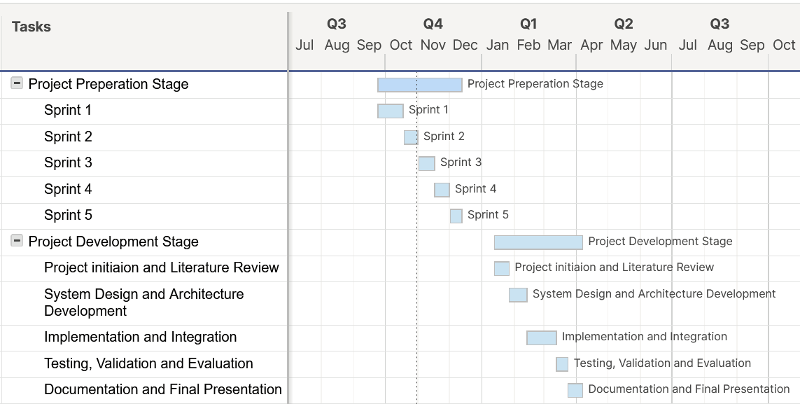

4. Budget and Resources

Resources
- Software: TBD
- Hardware: CPU based on x86 architecture, camera(s) for visual data, 32GB+ RAM, 256 GB+ Storage
- Frameworks/Protocols: HL7, FHIR, DICOM, RESTful APIs
- AI Tools: TensorFlow, PyTorch, Scikit-learn
- Version Control: GitHub
- Collaboration Tools: Trello, Microsoft Teams

5. Risk Management
Risk Register v1.0 16-11-25

6. Quality Assurance

6.1 Societal Benefits
The proposed secure, interoperable, and real-time digital decision support system will considerably enhance neonatal care outcomes by automating the data preprocessing for use in Hospital Information Systems (HIS) and AI-based diagnostic and monitoring systems. This will allow the clinicians to access required data on infant’s health faster and let AI-based diagnostics provide better results by eliminating the data before it is fed to the models which in turn will improve the care that can be provided. In the long term this may lead to improved survival rates for infants.
6.2 Economic Constraints
The project will prioritize open-source software and scalable cloud infrastructure to minimize costs. The proposed AI model shall be capable of performing inference on standard CPU hardware without requiring GPU acceleration.
6.3 Legal and Ethical Compliance
The system will strictly adhere to standards on medical data management and patient care. Patient confidentiality and informed consent will be priority and each part of the system will be built in accordance with these ethical principles.
6.4 Environmental Constraints
The use of cloud infrastructure and virtualized testing environments will reduce the need for physical hardware and associated energy consumption. Sustainable hosting providers and energy-efficient data centers will be prioritized to minimize carbon footprint.
6.5 Manufacturability
The proposed system, being a software-based digital decision support platform, will focus on scalability, maintainability, and replicability rather than physical manufacturability.
The software will be developed using open standards and well-documented APIs, enabling future updates, interoperability with other healthcare systems
6.6 Health considerations
The system will undergo extensive validation to ensure that data preprocessing does not introduce errors that could compromise patient care. The system will be evaluated against real-world hospital datasets under ethical approval

7. Appendix

8. References
- Health Level Seven International (HL7) Standards, www.hl7.org
- FHIR (Fast Healthcare Interoperability Resources), https://www.hl7.org/fhir/
- DICOM Standards Committee, Digital Imaging and Communications in Medicine (DICOM)

